**Challenge #2**

We need to write code that will query the meta data of an instance within aws and provide a json formatted output. The choice of language and implementation is up to you.

**Solution**:

This is something tricky. Metadata of an ec2 instance can be obtained from <http://169.254.169.254/latest/meta-data/>

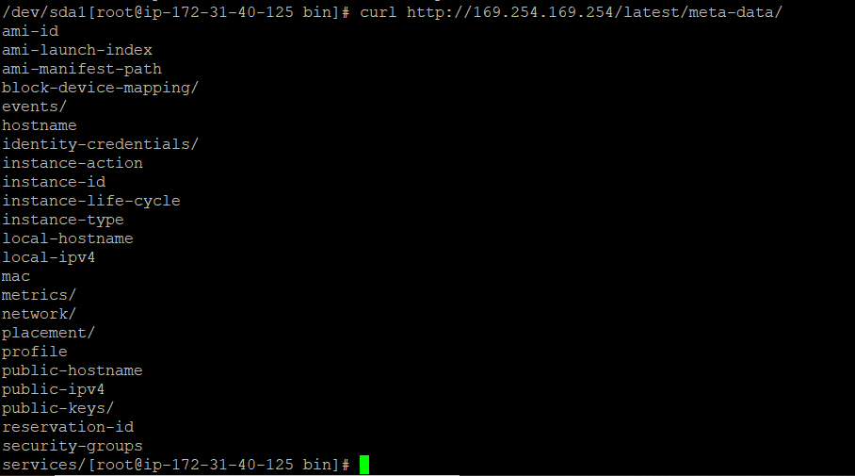

But not in json format.

So, if you ask me to get the data in JSON format I will go with some Go language

Note: I am not a Go language expert. But I can understand any language code quickly and can manipulate according to my needs. Below the Go script code (not my own. Got it from Internet) which can give the data in JSON format.



In above code, it was only retrieving only public-keys/ . However, I can modify this code to print all the meta data information in JSON format into a file. Just needed to extend the switch cases in the code.

The code allows for a particular data key to be retrieved individually

To achieve this, I would go with a wrapper shell script(on top of Go script) with an argument (particular Key) which does below – ./wrapper.sh ami-id

* Executes the above Go script and get the JSON data into a file(abc.json)
* Greps the key(ami-id) from the file(abc.json) and prints the value on the console.

I will write a shell script to execute the above go code and get the data into a file.